No Retreat, No Surrender (1986)
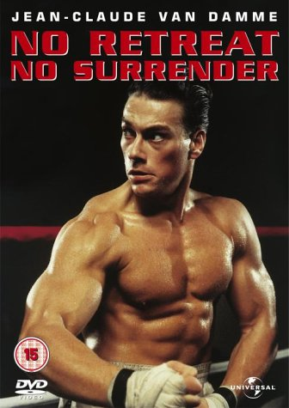
Summary:
Genre: Action / Drama
Jason Stillwell, a Bruce Lee fan, is beaten numerous times and trains from the ghost of Lee. Jason then... (More)
Director: Corey Yeun
Imdb Link - 4.1/10
Bloodsport (1988)

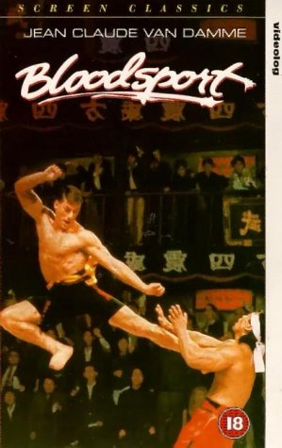
Summary:
Genre: Action / Sport
Frank Dux has spent most his life being trained by Tanaka to participate in the Kumite, the ultimate martial arts tournament... (More)
Director: Newt Arnold
Imdb Link - 5.8/10
Black Eagle (1988)

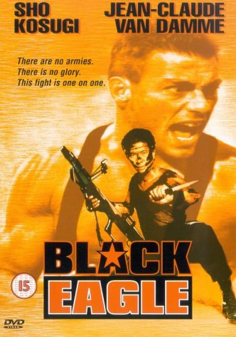
Summary:
Genre:
One of the US Air Force's most modern tactical aircrafts, a F-100 with a new laser guidance system, crashes into the sea near Malta... (More)
Director: Eric Karson
Imdb Link - 2.8/10
Cyborg (1989)
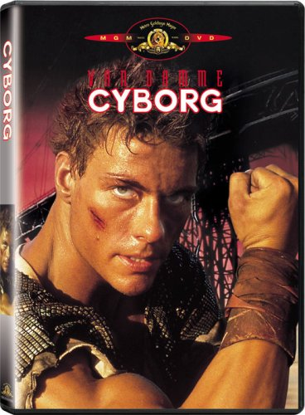
Summary:
Genre: Action / Sci-Fi
A martial artist hunts a killer in a plague-infested urban dump of the future. (More)
Director: Albert Pyun
Imdb Link - 4.1/10
Kickboxer (1989)
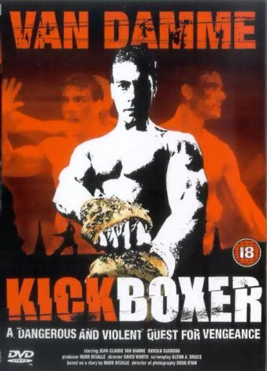
Summary:
Genre: Action / Drama / Sport
Kurt Sloan is the corner-man for his brother, U.S. kickboxing champion Eric Sloan. When Kurt witnesses... (More)
Director: Mark DiSalle & David Worth
Imdb Link - 5.0/10
Lionheart (aka A.W.O.L) (1990)
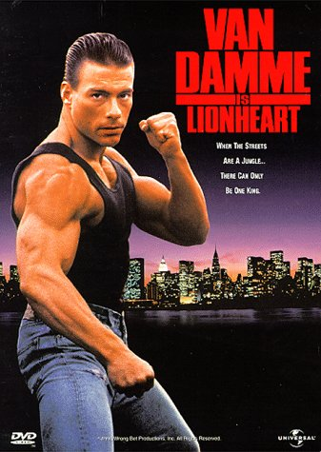
Summary:
Genre: Action / Drama / Sport
Lyon Gaultier is a deserter in the Foreign Legion arriving in the USA entirely hard up. He finds his brother between life and death and his sister-in-law without the money needed to heal her husband and to maintain her child. To earn the money needed, Gaultier decides to take part in some very dangerous clandestine fights. (More)
Director: Sheldon Lettich
Imdb Link - 5.1/10
Death Warrant (1990)

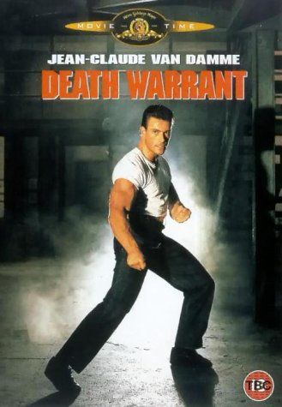
Summary:
Genre: Action / Drama / Mystery
The Canadian policeman Louis Burke is assigned in a jail to investigate in some murders of prisoners and jailors... (More)
Director: David S. Goyer
Imdb Link - 4.7/10
Double Impact (1991)
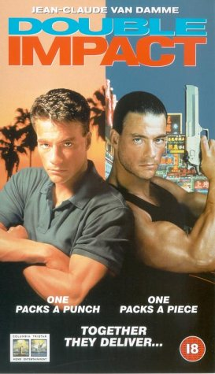
Summary:
Genre: Action
Jean Claude Van Damme plays a dual role as Alex and Chad, twins separated at the death of their parents... (More)
Director: Sheldon Lettich
Imdb Link - 4.3/10
Universal Soldier (1992)
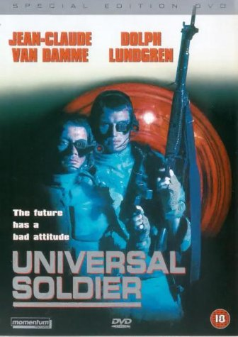
Summary:
Genre: Action / Drama / Sci-Fi
Luc and Scott were killed in Vietnam, but the army has a secret project for reanimating dead people as near-perfect soldiers. (More)
Director: Roland Emmerich
Imdb Link - 5.2/10
Nowhere to Run (1993)
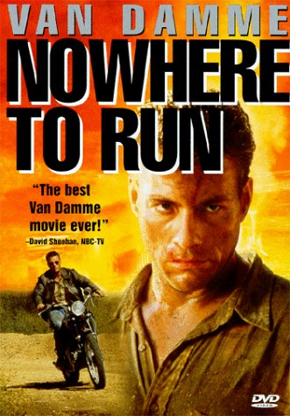
Summary:
Genre: Action / Romance / Drama
Escaped convict Sam Gillen single handedly takes on ruthless developers determined to evict Clydie - a widow with two young children... (More)
Director: Robert Harmon
Imdb Link - 4.7/10
Hard Target (1993)
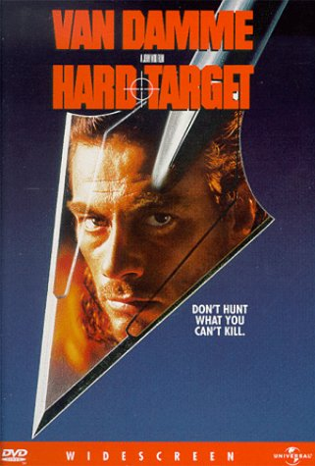
Summary:
Genre: Action / Thriller
A woman hires a drifter as her guide through New Orleans in search of her father, who has gone missing. They discover a deadly game of cat and mouse behind his disappearance in the process. (More)
Director: John Woo
Imdb Link - 5.4/10
Timecop (1994)

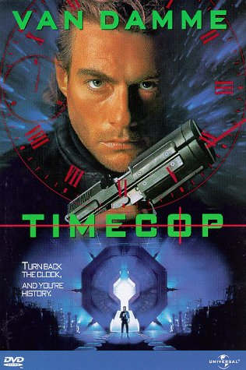
Summary:
Genre: Thriller / Action / Sci-Fi
An officer for a security agency that regulates time travel, must fend for his life against a shady politician who has a tie to his past. (More)
Director: Peter Hyams
Imdb Link - 5.4/10
Street Fighter (1994)

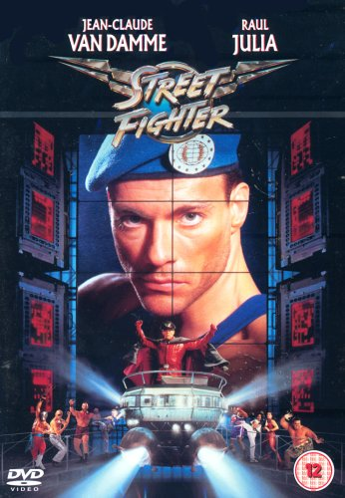
Summary:
Genre: Action / Adventure / Comedy
Col. Guile and various other martial arts heroes fight against the tyranny of Dictator M. Bison and his cohorts. (More)
Director: Steven E. de Souza
Imdb Link - 3.0/10
Sudden Death (1995)
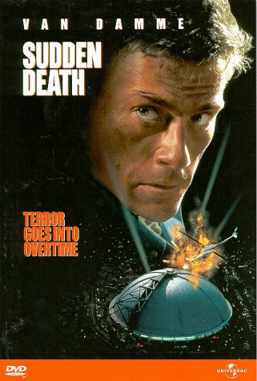
Summary:
Genre: Action / Drama / Thriller
A disgraced former fireman takes on a group of terrorists holding the Vice President and others hostage during the seventh game of the NHL Stanley Cup finals. (More)
Director: Peter Hyams
Imdb Link - 5.0/10
The Quest (1996)
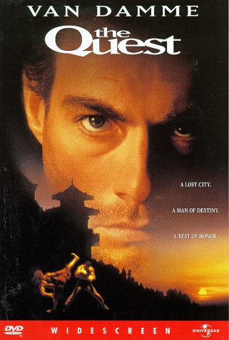
Summary:
Genre: Action / Adventure / Thriller
Chris embarks on an odyssey of self-discovery that spans the globe. Kidnapped and enslaved by gun smugglers... (More)
Director: Jean Claude Van Damme
Imdb Link - 4.4/10
Maximum Risk (1996)
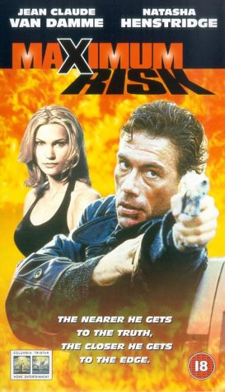
Summary:
Genre: Action / Adventure / Thriller
A policeman takes his twin brother's place and inherits his problems and a beautiful girlfriend. He is forced to kickbox his way from France to the U.S. and back while playing footsie with the FBI and Russian mafia. (More)
Director: Ringo Lam
Imdb Link - 4.8/10
Double Team (1997)
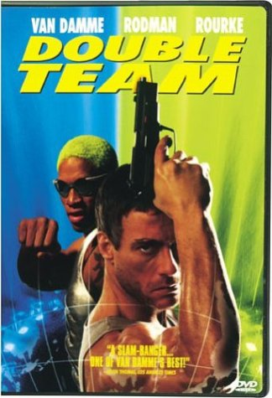
Summary:
Genre: Action / Thriller
Counter-terrorist Jack Quinn misses his target, Stavros, on the eve of his final mission. From there, he is sent to "The Colony", a rebirth for presumed-dead assassins. (More)
Director: Hark Tsui
Imdb Link 3.8/10
Knock Off (1998)
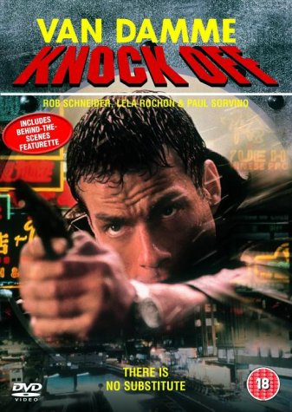
Summary:
Genre: Action / Thriller
Action star Jean Claude Van Damme plays a fashion designer who must join forces with a C.I.A. agent to combat terrorism. (More)
Director: Hark Tsui
Imdb Link - 3.8/10
Legionnaire (1998)
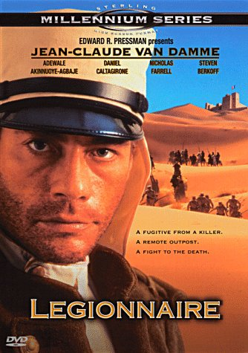
Summary:
Genre: Action / Adventure / Drama / War
Alain Lefevre is a boxer paid by a Marseille mobster to take a dive. When he wins the fight he attempts... (More)
Director: Peter MacDonald
Imdb Link - 4.4/10
Universal Soldier: The Return (1999)
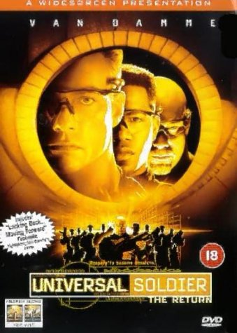
Summary:
Genre: Action / Sci-Fi
The "universal soldiers" (led by Van-Damne) must fight the whole army. When the military's supercomputer S.E.T.H (White) gets out of control... (More)
Director: Mic Rodgers
Imdb Link - 3.0/10
Desert Heat(1999)
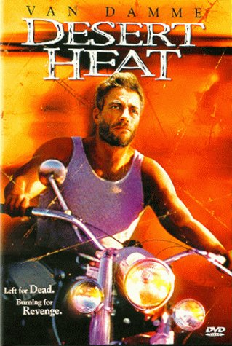
Summary:
Genre: Action
In the spring, the full moon shines for the warrior who has lost his way. Coyote is the spirit that leads back to life. If he follows the coyote when the moon is full, the warrior will see the path once more... (More)
Director: John G. Avildsen
Imdb Link - 4.1/10
Replicant (2001)
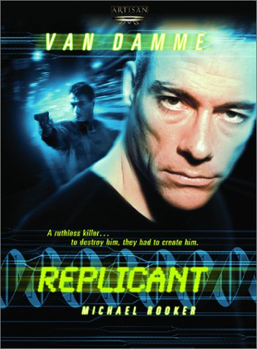
Summary:
Genre: Action / Sci-Fi / Thriller
Scientists create a genetic clone of a serial killer in order to help catch the killer, teaming up with two cops. (More)
Director: Ringo Lam
Imdb Link - 4.9/10
The Order (2001)
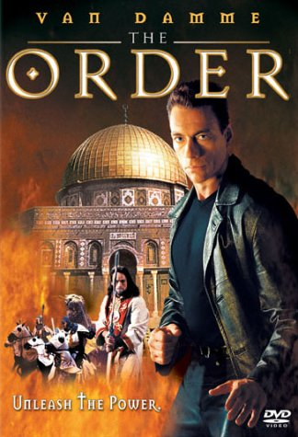
Summary:
Genre: Action / Adventure / Drama / Thriller
Van Damme plays Rudy whose father, Oscar is an archaeologist. His father goes to Israel. When his father disappears... (More)
Director: Sheldon Lettich
Imdb Link - 4.2/10
Derailed (2002)
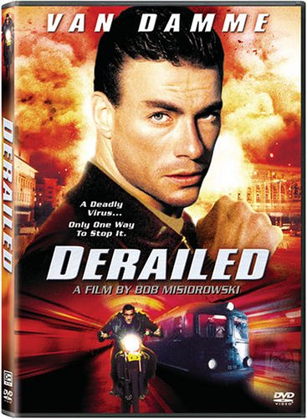
Summary:
Genre: Action / Thriller
On an out of control train holding hostages and high-tech bio-weapons agent Kristoff (Van Damme) becomes... (More)
Director: Bob Misiorowski
Imdb Link - 3.1/10
In Hell (2003)
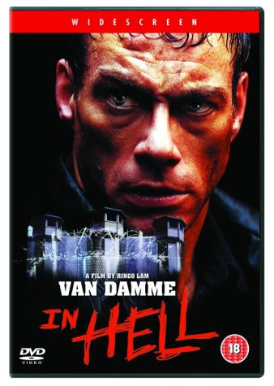
Summary:
Genre: Action / Thriller / Drama
A man must survive a prison where hardened criminals battle to the death for the warden's entertainment. (More)
Director: Ringo Lam
Imdb Link - 5.6/10
Wake of Death (2004)
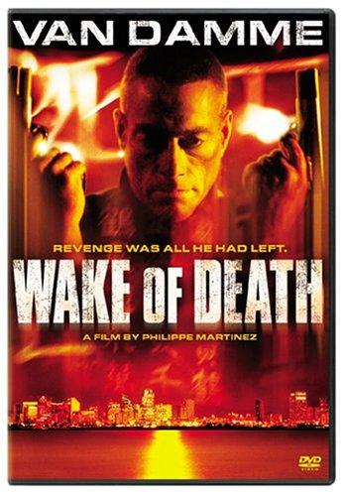
Summary:
Genre: Action / Adventure
After his wife is brutally murdered, an ex-cop wages war against the Chinese triads. (More)
Director: Philippe Martinez
Imdb Link - 5.3/10
Second in Command (2006)
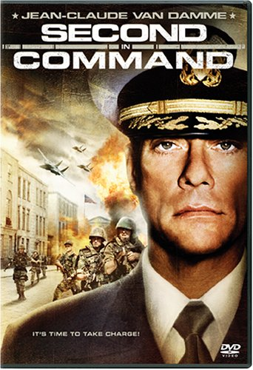
Summary:
Genre: Action / Thriller
Jean Claude plays an official who's just been appointed as Second In Command to the U.S.Ambassador at an American Embassy in a small... (More)
Director: Simon Fellows
Imdb Link - 5.1/10
The Hard Corps (2006)
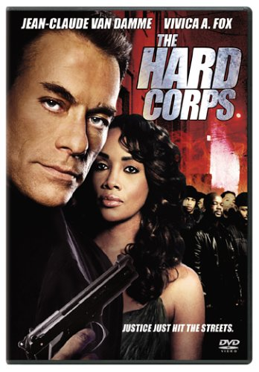
Summary:
Genre: Action / Thriller
Jean-Claude will be playing a Combat Vet who's just spent the last 3 years fighting in Afghanistan and Iraq... (More)
Director: Sheldon Lettich
Imdb Link - 5.3/10

